Mnemonic on the 7 living process
A very common requirement in education, and especially biological science (the type of science we are doing now), is having to remember key facts. A lot of the time these key facts may not have an idea which closely links them and they may appear to be somewhat random key facts.
The video you saw in the Stileapp, on the characteristics of living things, mentioned seven characteristics which all living things do. These are key facts that scientists use to identify living things – so you should try remembering them.
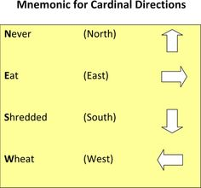
A common memory technique (there are two techniques, and they are related) is Mnemonics. A mnemonic is where you take the first letter of each key fact and make a single sentence out of them. Some examples are
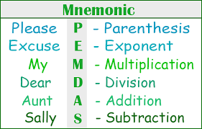
The seven characteristics mentioned in the stileapp are listed below. Each has their first letter underlined.
TASK – construct a mnemonic based on the seven letters. Type your mnemonic in the space below.
Movement Respiration Sensitivity Growth Reproduction Excretion Nutrition

